**Group Project Milestone 4**

**Final Report**

**Group 1**

Madhurima Kar

Dipsa Prusty

Avinash Ravikumar

Anantha Shashidhar Karunakaram

Ravali Nimmaneni

**Naveen Jindal School of Management**

**University of Texas at Dallas**

Contents

Executive Summary 4

System Proposal and Problem Statement 4

Project Name: 4

Project Sponsor and Stakeholder: 4

Business Need: 5

Project Scope: 5

Project Objectives: 6

Expected Value: 6

Assumptions: 6

Requirements Definition 7

Functional Requirements: 7

Non-Functional Requirements: 7

Structural Model 7

Behavioral Model 8

Use Case for user login system 8

Use Case for adding balance to comet app 9

Use Case for Payment to vendor 10

Use Case for Accessing Facilities 11

Dynamic Models 12

sequence diagram for adding balance to the CometApp 12

sequence diagram for payment to vendors 12

sequence diagram for accessing facilities 13

Design Documents 14

User Interface Design 14

Control Specifications 15

Software Design Specifications 16

Testing 19

Test Case for registering a new student 19

Test case to verify student login 19

Test Case to make payment to vendors 20

Project Management Documents 20

Work Breakdown Structure 21

Implementation 21

Meeting Minutes 22

Lessons learned 29

# Executive Summary

CometApp is a mobile application that would facilitate the UTD students to avail all facilities without using the Comet Card physically. This will also be a new payment option and it would help students to access various campus facilities.

CometApp will help students to make easy and secure purchases. Students will have access to UTD library, printing lab, activity center, dining halls, parking, bookstore etc. without swiping the comet card which will simplifies the process. This app will be user friendly and will provide a better experience for the student community. Students can enjoy this facility without paying any extra fee.

We would tie-up with vendors who are already accepting Comet Cards for various services to implement the payment services through the CometApp. Revenue model would be based upon advertisements for our vendors and transaction fee (specific percentage that will be decided upon). The payments would me made using NFC technology and bio-metric identification, which is now becoming popular among most smartphones. To facilitate this, we need to make some hardware changes so that machines used by vendors can read the physical comet card as well as support CometApp.

We would first run a pilot program for 3 months within Jindal School and collect necessary data and feedback to improvise. We can then expand the project to include the other schools within UTD. For the overall project, we have an estimate of $200,000. Benefits of up to $40,000 per month are expected when launched completely. In the long run, we can make this app available for faculties and visitors with additional features like making parking payment easier, placing online orders etc. With this proposal, we request your funding and support to initiate the pilot of CometApp.

# System Proposal and Problem Statement

## Project Name:

CometApp

## Project Sponsor and Stakeholder:

|  |  |  |
| --- | --- | --- |
| **ROLE** | **RESPONSIBILITIES** | **PARTICIPANTS** |
| Project Sponsor | * Provide funding * Provide business expertise and guidance to the project manager and the team * He acts as the link between the project, the business community and management decision making groups | Prithi Narasimhan |
| Project Manager | * Provide project direction and lead the team members towards the project objectives * Manages the project budget, schedule, risk and delivery * Managing project according to the project plan | Tim Cook |
| Project participants | * Understanding the requirements and presenting a business model to meet the demands * Providing project status reports on a regular basis * Making the project deliverables available as per the project schedule * Identify risks and ensure business continuation | Madhurima Kar  Dipsa Prusty  Avinash Ravikumar  Anantha Shashidhar Karunakaram  Ravali Nimmaneni |
| Users | * Use the application * Provide feedback and reviews | All UTD students |

## Business Need:

Existing system demands students to carry their physical comet cards for accessing various services at the university. Most of the students do not like carrying an extra card considering the probability of losing or having a card damaged restricts the students from accessing the services. This is where CometApp mobile application comes to rescue. Access to Laboratory and printing labs, activity center, library – issuing books, study room reservation, dinning plan made easy. This application can be used for payments at various stores and cafeterias in campus, vending machines. For payments at various locations off campus, e.g., six flags, car wash, restaurants.

## Project Scope:

CometApp is a mobile application designed to render services to students as an alternative to Comet card.

Within the project scope is designing mobile application or providing the services. The application will have different services that can be accessed both on campus and off campus. To manage the application, we will have to choose a maintenance company with good standards for the application. The application needs to be tested and updated on a regular basis. We need to have an option to add and delete certain functionalities for a better usability. Students will be able to view and track the past activities. Two level security protection would be provided as an additional feature for the application to maintain confidentiality of student data. Students can transfer money from bank accounts into the CometApp mobile application through Credit Cards, Debit Cards or by linking to PayPal. CometApp will be supported by all the platforms like Android, iOS etc.

Use of CometApp mobile application will be restricted to UT Dallas student community. UT Dallas faculties and staffs will not be covered under this plan. Guest pass students who visit campus for a temporary period would not be able to avail the CometApp services. A standalone desktop application would not be developed but the students can browse their application details on the CometApp web portal. Using the CometApp to any campus dining area more than a thrice a day is not permitted.

## Project Objectives:

CometApp will facilitate the UTD students to avail all facilities without using the comet card physically. CometApp is a mobile application which is simple and yet unique. It has excellent services which offer a great value to the students through the following features:

* Simple user interface design that will make the interaction easier
* Easy navigation
* Frequently updated database of students is maintained
* Every student using this application can keep track of past activities
* Notification alerts students for any changes or updates

## Expected Value:

* Our main objective is to make the listed features available for the application.
* This would provide satisfying services to the students
* Since the application is related to financial transactions, it should be secured enough
* Overall CometApp should be cost effective without compromising with the quality
* All milestones of the project will be delivered in time
* We expect to make 80% UTD students our satisfied customers in the first year of operation

## Assumptions:

* All UTD facilities and stores which require use of comet cards will accept the CometApp mobile application
* Merchandise off-campus will permit the use of this application as an alternative to comet card
* The application will be compliant to federal and industry standards relating to mobile application and financial transactions
* CometApp will be PCI compliant (Payment Card Industry)

# Requirements Definition

## Functional Requirements:

* The user should be able to register with the application
* The user should be able to add balance to his comet app using multiple payment methods
* The application shall store all access logs and payment history
* Enforce two factor authentications for resetting credentials

## Non-Functional Requirements:

* The application should be compatible with all mobile operating systems
* Error messages should be displayed in case of exceptions
* Downtime for the application should be less than 5 hours
* The application should be ready to respond to users input in less than 10s

# Structural Model

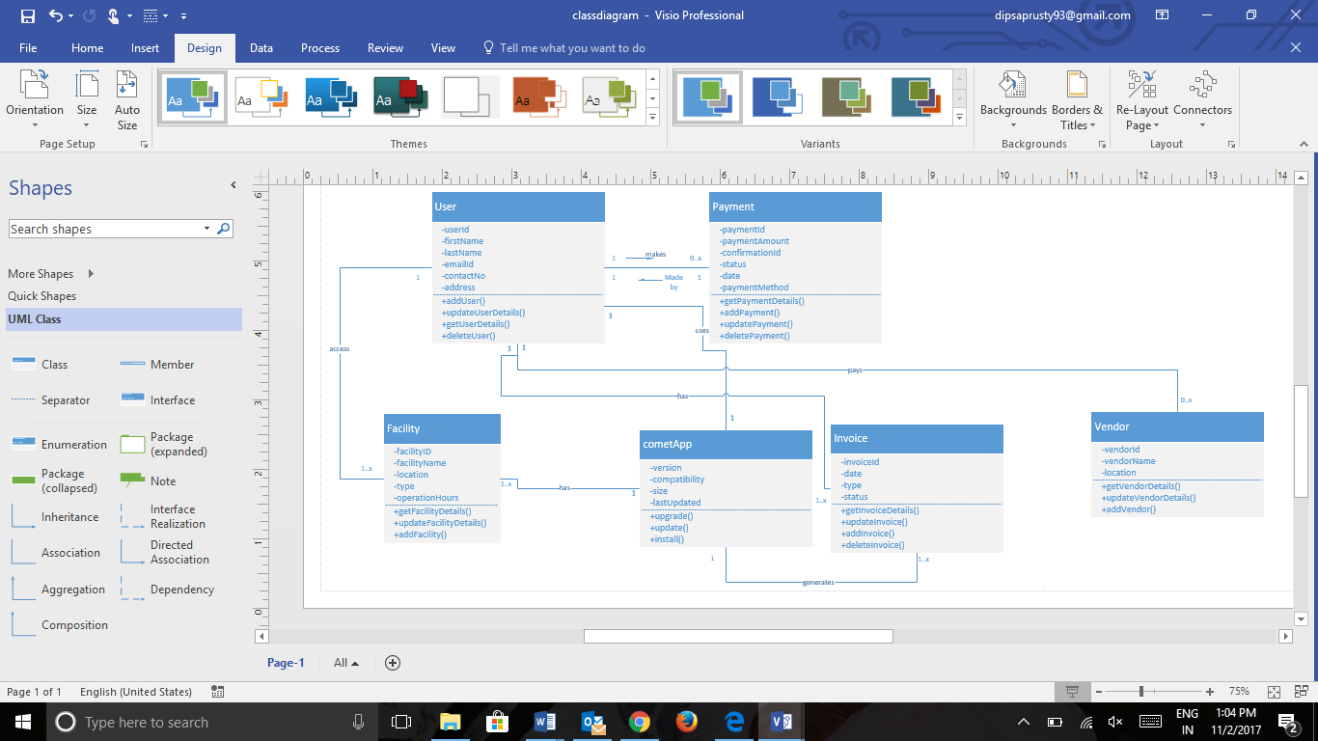

# Behavioral Model

## Use Case for user login system

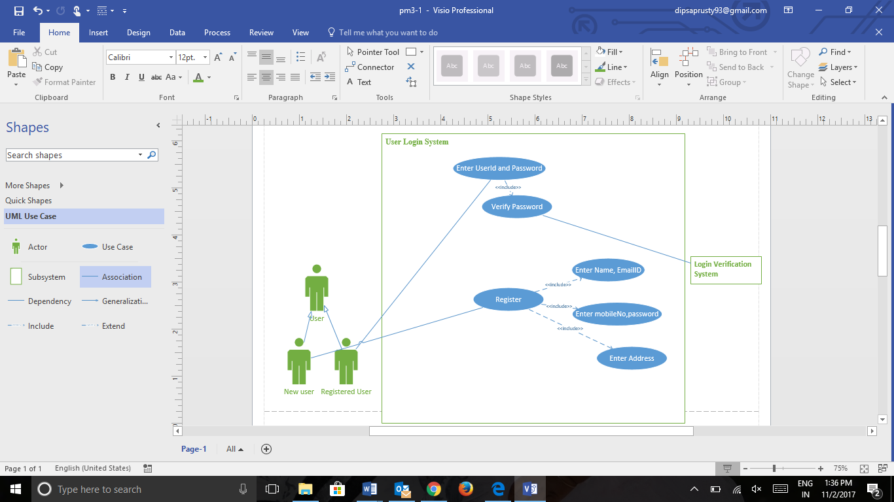

|  |  |
| --- | --- |
| Use Case Name: | User Login System |
| Primary Actor: | User |
| Brief Description: | This use-case describe how would a user login or a new user creates an account. |
| Normal flow of events: | 1.User enters username  2.User enters password  3.Application validates credentials |
| Alternate/Exception flow: | 1.a. Enter First name, Last name  2.a. Enter email, username, password  3.a. Enter credit card information  4.a. Create Account |

## Use Case for adding balance to comet app

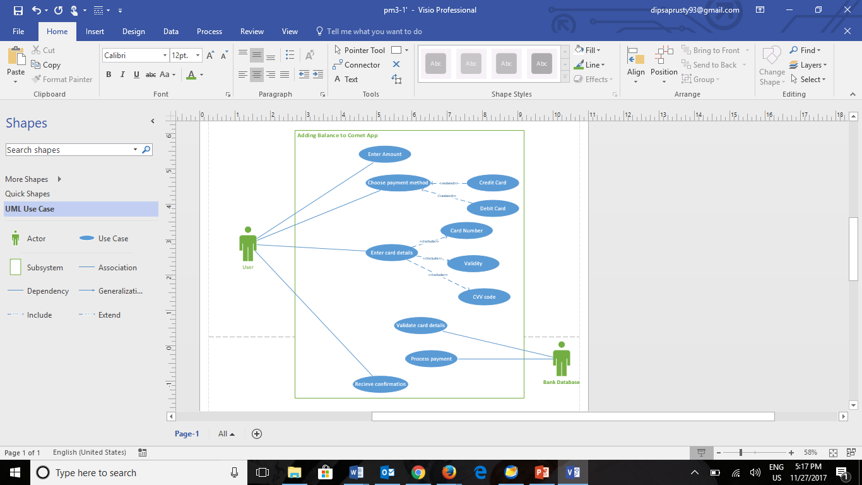

|  |  |
| --- | --- |
| Use Case Name: | Adding balance to Comet App |
| Primary Actor: | User |
| Brief Description: | This use-case describe how would a user add balance to his/her Comet App |
| Normal flow of events: | 1.User enters username  2.User enters password  3.Application validates credentials  4.User asked to enter amount he wants to add to his balance  5.Choose payment option  6.Prompt for card details.  7.Balance updated. |
| Alternate/Exception flow: | 1.Add new payment method(If the user wants to add balance in his account using a different payment method)  2.Enter Card Details  3.Update Balance |

## Use Case for Payment to vendor

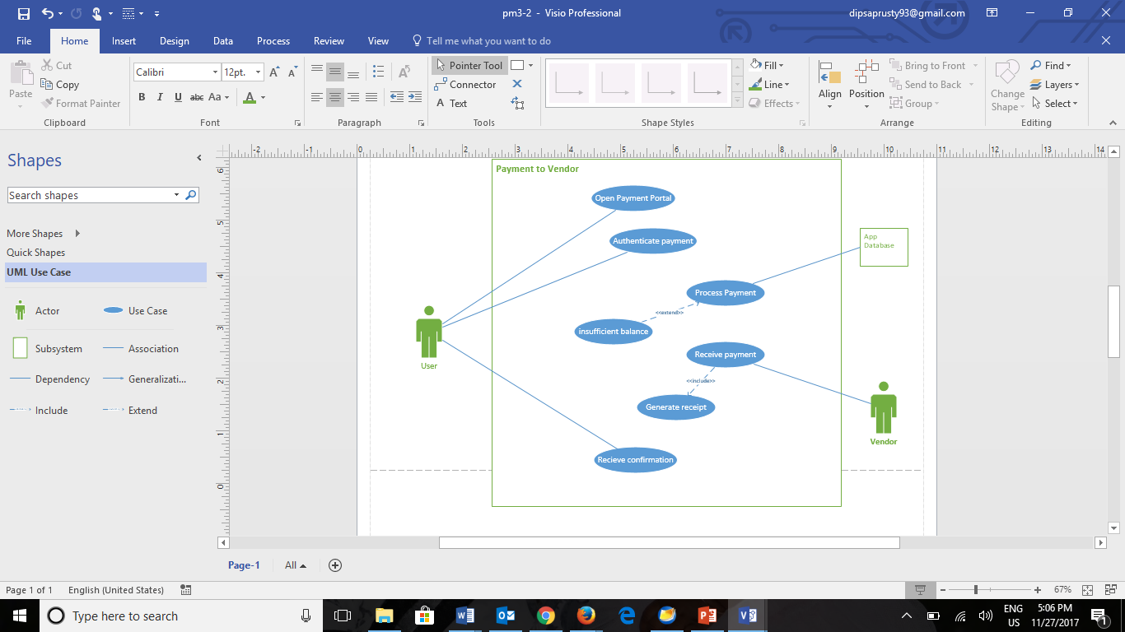

|  |  |
| --- | --- |
| Use Case Name: | Payment to Vendor |
| Primary Actor: | User |
| Brief Description: | This use-case describe how would a user make a payment to vendor through Comet App |
| Normal flow of events: | 1.Enter login details.  2.open payment portal.  3.Authenticate payment  4.Bank processes the payment  5.Payment received by vendor  6.Receipt generated |
| Alternate/Exception flow: | 1. If the user has insufficient balance in his account, he will be prompted to add balance to his account before making payment  2.Add Balance  3.Authenticate Payment |

## Use Case for Accessing Facilities

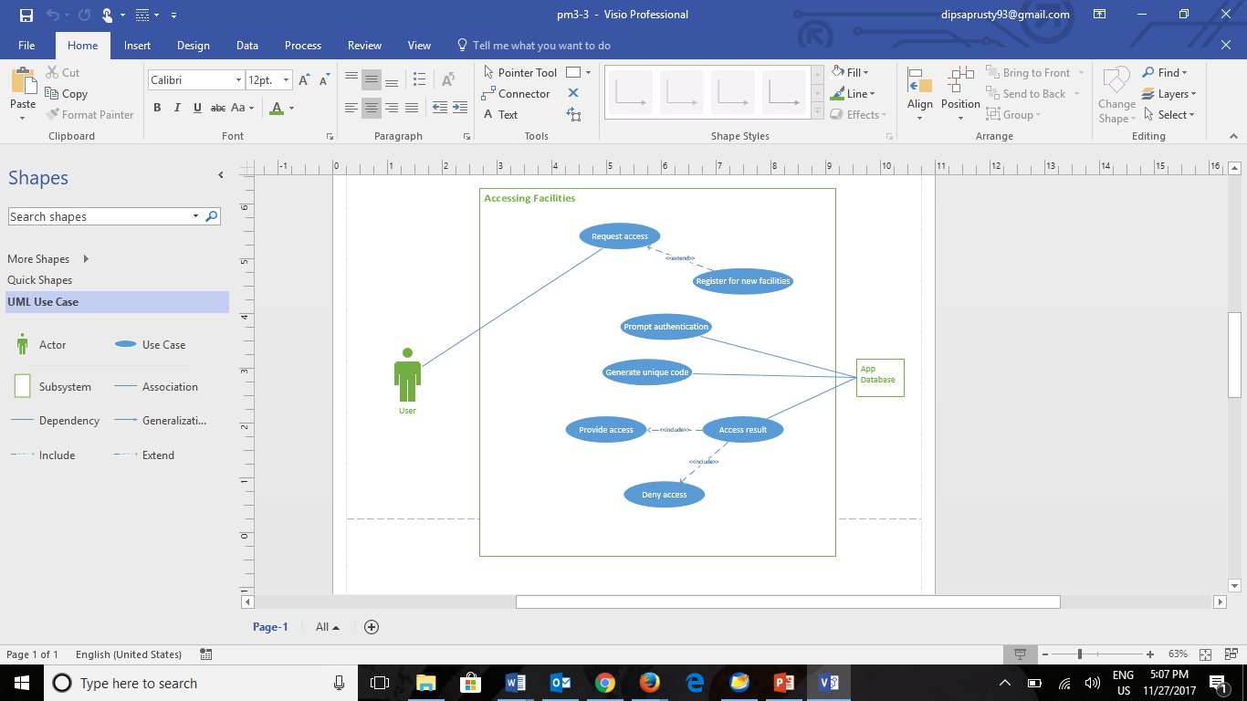

|  |  |
| --- | --- |
| Use Case Name: | Accessing facilities |
| Primary Actor: | User |
| Brief Description: | This use-case describe how would a user can access facilities enrolled facilities or new facilities. |
| Normal flow of events: | 1.Request access for enrolled facility  2.Prompt Authentication  3.Application generates unique code in order to verify the user  4.Once the user verifies the unique code with the system access is provided |
| Alternate/Exception flow: | 1. For accessing a new facility, first the user has to register for it.  2.If it’s a paid facility, user has to make the payment.  3.Enrolled facility list will be updated in his application  4.Request access for the facility |

# Dynamic Models

## sequence diagram for adding balance to the CometApp

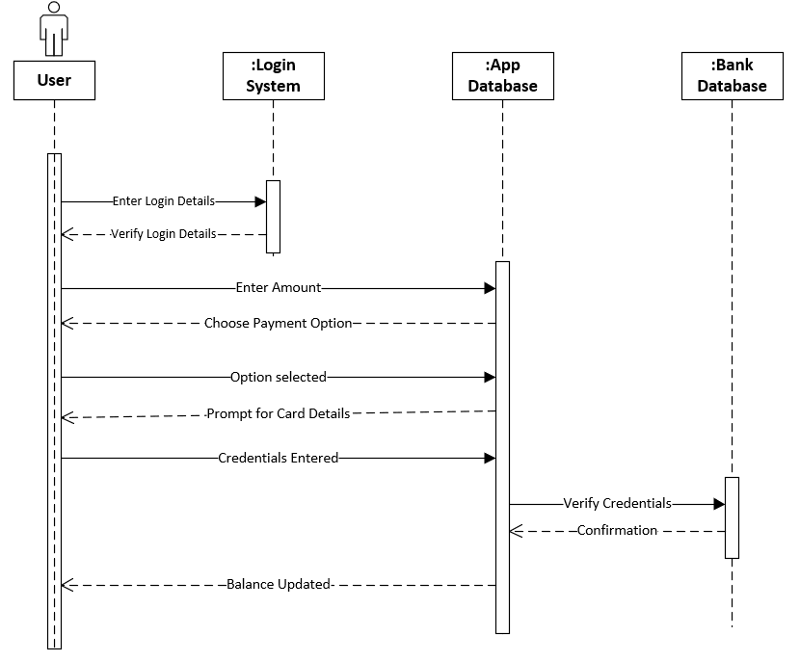

## sequence diagram for payment to vendors

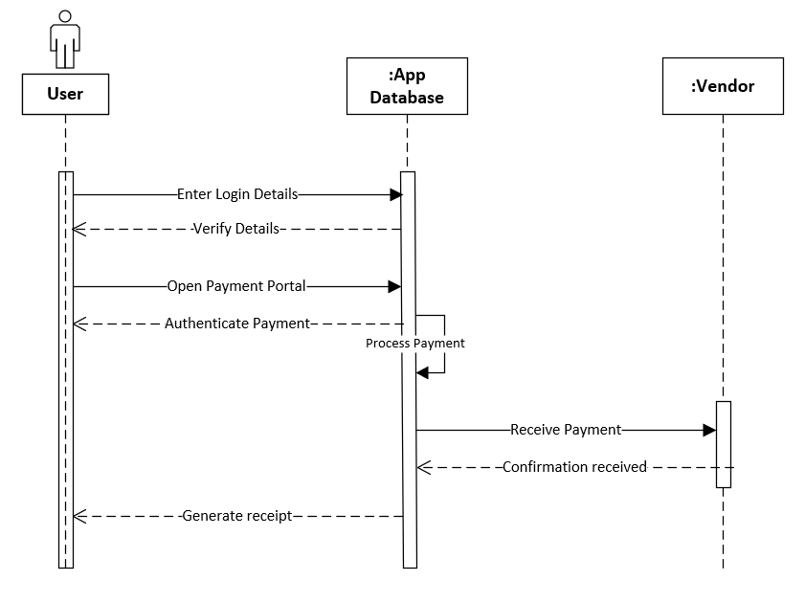

## sequence diagram for accessing facilities

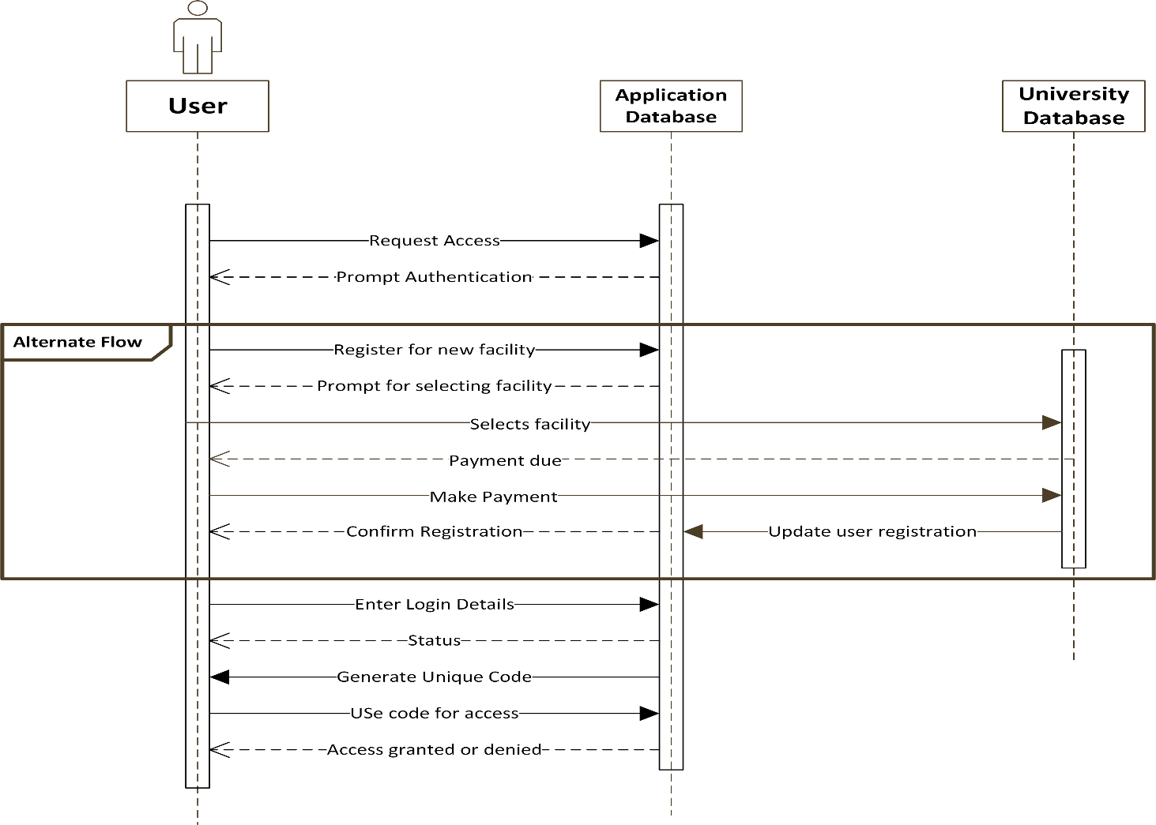

# Design Documents

## User Interface Design

1. User Login UI

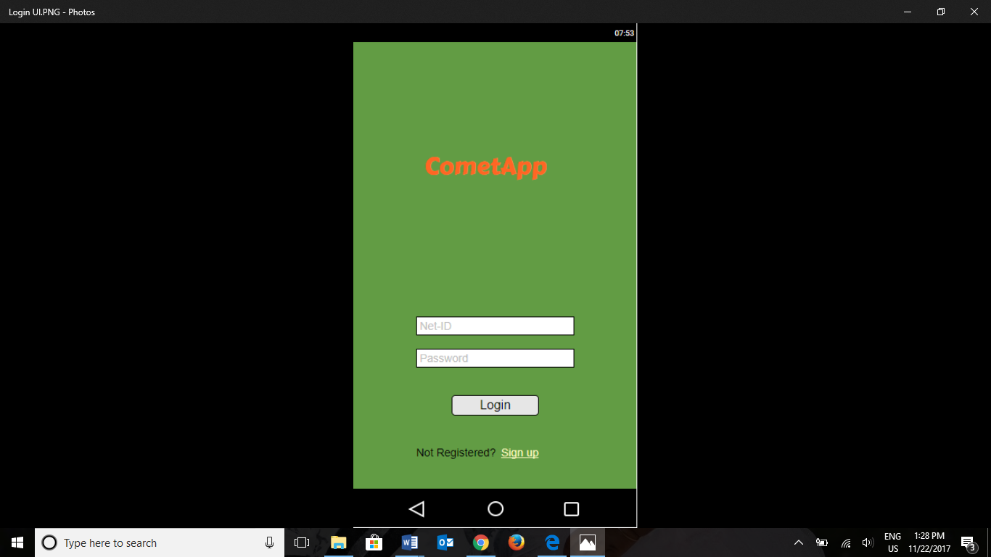

1. Adding balance to CometApp

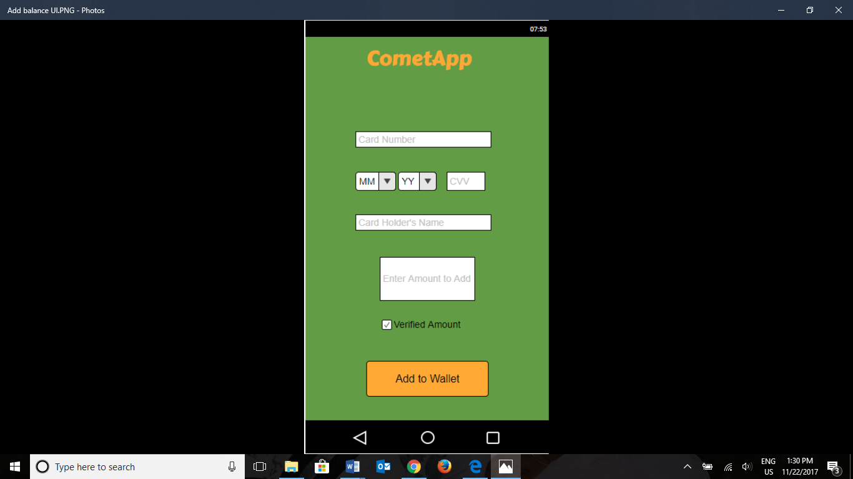

1. For accessing facility

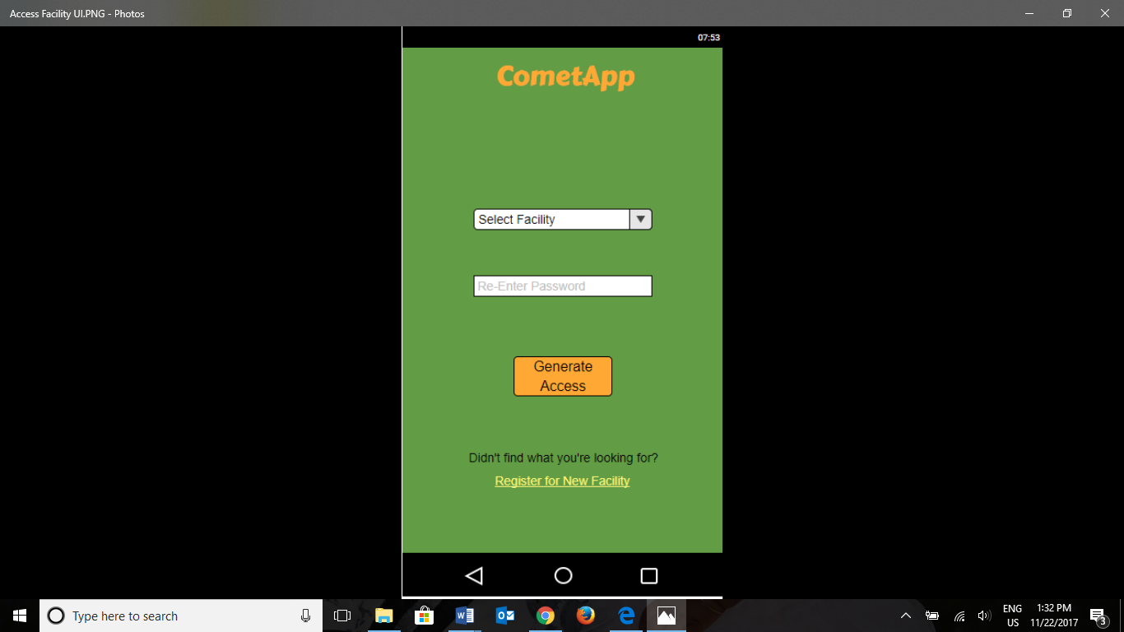

## Control Specifications

Control objects control the flow of the application, direct the sequencing of events, manage the interaction among objects, and are often used to encapsulate control related to a specific use case.

1. Login Verification: The Login verification method is an entry control and will help to detect fraudulent/malicious activity. Only a registered user who has a valid comet card can login through the system. This control method will carry out checks for user ID and password. After 3 unsuccessful attempts to login, the system will prompt to reset the password for the account for security purpose.
2. Method Specifications: For processes like adding balance to the CometApp, there can be multiple security processes. Before processing adding balance method, it checks if the card used to add balance has a valid 16-digit number, validates the CVV code and expiry date with the card company database. This can help keep a check on fraud transactions.
3. Access Control Manager: This system keeps a track of all the available facilities for the logged in user and adds a new facility when the user registers for a new facility. It also deletes facilities when the registration of the user expires, or the user drops out of an activity.

## Software Design Specifications

1. **Method to register a new student**

|  |  |  |
| --- | --- | --- |
| **Method Name:** RegisterStudent | **Class Name:** Student | |
| **Description of responsibilities:**  Implement the necessary behavior to register a student. | |
| **Arguments Received:** | **Data type:** | |
| FirstName | String | |
| LastName | String | |
| NetId | String | |
| UTDEmailAddress | String | |
| Password | String | |
| ContactNumber | Number | |
| **Return Value:** | **Data Type:** | |
| RegisterStatus | Boolean | |
| **Message and Example:** | | |
| RegisterStudent( FirstName, LastName, NetId, UTDEmailAddress, Password, ContactNumber) : String  RegisterStatus = RegisterStudent( “Dipsa”, “Prusty”, “[dxp170230”,](mailto:foo@bar.com) “dxp170230@utdallas.edu’, “Password”, 469123456) | | |
| **Algorithm Specification:** | | |
| Check if given email address is already registered  Connect to the database  If email provided already exists in the database  Set RegisterStatus = “Already Registered”  Return RegisterStatus  If given email address is not registered  Check if the email ID is registered in UTD current student database  If it exists, extract student data from UTD database  Prompt for setting Password  Set RegisterStatus = “Registered”  Return RegisterStatus  End If  If the emailID is not listed in the UTD database  Throw error message “Incorrect EmailID”  End If | | |

1. **Method to verify Student Login**

|  |  |
| --- | --- |
| **Method Name:** VerifyStudentLogin | **Class Name:** Student |
| **Description of responsibilities:**  Implement the necessary behavior to verify the login credentials of the student. | |
| **Arguments Received:** | **Data type:** |
| UTDEmaiId | String |
| Password | String |
| **Return Value:** | **Data Type:** |
| LoginStatus | Boolean |
| **Message and Example:** | | |
| VerifyStudentLogin (UTDEmailId, password): String  LoginStatus = verifyStudentLogin (“dxp170230@utdallas.edu”, “password”) | | |
| **Algorithm Specification:** | | |
| Check for valid student login id and password   1. If loginID and password is null or has spaces then   Set LoginStatus = “Fail”  Return LoginStatus   1. If LoginID and password is not null and doesn’t have spaces   Retrieve login id and password from database  --Check for valid login id  If valid login id  --check for valid password  If valid password  Set LoginStatus = “Success”  Return LoginStatus  Else  Set LoginStatus = “Fail”  Return LoginStatus  End if  Else  Set LoginStatus = “Fail”  Return LoginStatus  End if | | |

1. **Method to make payment to vendors through CometApp**

|  |  |
| --- | --- |
| **Method Name:** MakePayment | **Class Name:** Student |
| **Description of responsibilities:**  Implement the necessary behavior to make payment to vendors through CometApp. | |
| **Arguments Received:** | **Data type:** |
| UTDEmaiId | String |
| Password | String |
| VendorID | String |
| VendorName | String |
| AmountPayable | Number |
| **Return Value:** | **Data Type:** |
| TransactionID | Number |
| **Message and Example:** | | |
| MakePayment (UTDEmailId, password, VendorID, VendorName, AmountPayable): String  PaymentStatus = MakePayment (“dxp170230@utdallas.edu”, “password”, “123”, “Subway”, “$7”) | | |
| **Algorithm Specification:** | | |
| 1. Check for valid Student credentials   If the credentials are invalid, return to login page   1. Select vendor 2. Enter amount you want to pay to vendor   If available balance is less than amount entered  Prompt user to add balance  Else  Complete payment and generate receipt  End If | | |

# Testing

## Test Case for registering a new student

**Purpose:**

To make sure that a new student registers for using Comet App.

**Prerequisite:**

The person should be a current student of The University of Texas at Dallas.

The student should hold a valid NET ID provided by the University.

**Test Data:**

FirstName = [Valid FirstName, Invalid FirstName, Empty]

LastName = [Valid LastName, Invalid LastName, Empty]

NetId = [Valid NetID, Invalid NetID, Empty]

UTDEmailAddress = [Valid UTDEmailAddress, Invalid UTDEmailAddress, Empty]

ContactNumber = [Valid ContactNumber, Invalid ContactNumber, Empty]

Password = [Valid Password, Invalid Password, Empty]

**Procedure:**

|  |  |
| --- | --- |
| **Steps** | **Expected result** |
| On the Comet App Home page, the student clicks on register | The student is directed to the registration page |
| On the registration screen, details like FirstName, LastName, NetID, UTDEmailAddress, ContactNumber and Password is entered. | Student should be able to enter all these details. |
| Click on REGISTER button. | Student is registered and redirected to the home page. |

## Test case to verify student login

**Purpose:**

To verify the login credentials of a student and make sure that he/she can login.

**Prerequisite:**

The student should have already finished registration with the Comet App.

**Test Data:**

UTDEmailID = [Valid UTDEmailID, Invalid UTDEmailID, Empty]

Password = [Valid Password, Invalid Password, Empty]

**Procedure:**

|  |  |
| --- | --- |
| **Steps** | **Expected result** |
| Click on the Login link. | Student will be redirected to the Login Page. |
| Enter the Login ID ie. UTDEmailID and the Password. | Student should be able to enter the required details. |
| Click on the Login button. | Student should be able to login if the credentials are valid.  If the login credentials are invalid, throw Login status as Failed. |

## Test Case to make payment to vendors

**Purpose:**

To make sure that the payments made by students through Comet App are paid to the vendors.

**Prerequisites:**

The student is already registered with Comet App.

The vendor is already signed up with the Comet App and has a Vendor ID.

**Test Data:**

UTDEmailID = [Valid UTDEmailID, Invalid UTDEmailID, Empty]

Password = [Valid Password, Invalid Password, Empty]

VendorID = [Valid VendorID, Invalid VendorID, Empty]

VendorName = [Valid VendorName, Invalid VendorName, Empty]

AmountPayable = [Valid AmountPayable input, Empty]

|  |  |
| --- | --- |
| **Steps** | **Expected result** |
| Student enters the credentials | Validate the student credentials |
| Select the vendor for appropriate service | The service is rendered |
| Enter the Amount to be paid to vendor | The amount for the service is paid.  In case of insufficient balance, a prompt is thrown INSUFFICIENT BALANCE. |
| Complete payment | Payment made and the Invoice is generated. |

# Project Management Documents

## Work Breakdown Structure

## Implementation

|  |  |  |  |  |  |
| --- | --- | --- | --- | --- | --- |
| Task Name | Predecessor | Effort | Estimated  Start Date | Estimated End Date | Assigned Resource(s) |
| 1.0 Initiation |  |  |  |  |  |
| 1.1 Requirements gathering |  | 5 days | Wed 9/20/17 | Tue 9/26/17 | Avinash, Madhurima |
| 1.2 Develop Project charter | 1.1 | 3 days | Wed 9/27/17 | Fri 9/29/17 | Ravali, Dipsa |
| 1.3 Project charter approved | 1.2 | 2 days | Mon 10/2/17 | Tue 10/3/17 | Shashidhar |
| 2.0 Planning | 1.0 |  |  |  |  |
| 2.1 Develop scope statement | 1.0 | 2 days | Wed 10/4/17 | Wed 10/5/17 | Madhurima, Avinash |
| 2.2 Develop project plan | 2.1 | 4 days | Fri 10/6/17 | Wed 10/11/17 | Shashidhar, Dipsa |
| 2.3 Project schedule | 2.2 | 2 days | Thu 10/12/17 | Fri 10/13/17 | Ravali, Dipsa |
| 2.4 Project budget | 2.3 | 1 day | Mon 10/16/17 | Mon 10/16/17 | Avinash, Shashidhar |
| 2.5 Requirements documentation | 2.2 | 1 day | Thu 10/12/17 | Thu 10/12/17 | Madhurima |
| 2.6 Project plan approved | 2.1-2.5 | 2 days | Tue 10/17/17 | Wed 10/18/17 | Madhurima, Ravali |
| 3.0 Execution | 2.0 |  |  |  |  |
| 3.1 Kick off meeting | 2.6 | 1 day | Thu 10/19/17 | Thu 10/19/17 | Dipsa, Avinash |
| 3.2 Verify requirements | 3.1 | 5 days | Fri 10/20/17 | Thu 10/26/17 | Shashidhar |
| 3.3 System design | 3.2 | 10 days | Fri 10/27/17 | Fri 11/09/17 | Ravali, Madhurima |
| 3.4 Database design | 3.3 | 7 days | Fri 11/10/17 | Mon 11/20/17 | Dipsa, Shashidhar, Avinash |
| 3.5 Application development | 3.4 | 15 days | Tue 11/21/17 | Mon 12/11/17 | Ravali, Madhurima |
| 3.6 Test the application | 3.5 | 15 days | Tue 12/12/17 | Mon 1/1/18 | Ravali, Madhurima |
| 3.7 Status Report | 3.1-3.6 | 1 day | Tue 1/2/18 | Tue 1/2/18 | Dipsa |
| 4.0 Monitoring and Control | 3.3 |  |  |  |  |
| 4.1 Performance evaluation | 3.3-3.5 | 2 days | Tue 12/12/17 | Wed 12/13/17 | Shashidhar |
| 4.2 Update changes | 4.1 | 2 days | Thu 12/14/17 | Fri 12/15/17 | Avinash |
| 4.3 Performance reports | 4.1 | 1 day | Thu 12/14/17 | Thu 12/14/17 | Ravali |
| 5.0 Closing |  |  |  |  |  |
| 5.1 Documentation and presentation | 4.3 | 2 days | Fri 12/15/17 | Mon 12/18/17 | Madhurima |
| 5.2 Lessons learned | 5.1 | 1 day | Tue 12/19/17 | Tue 12/19/17 | Avinash |
| 5.3 Closing report | 5.2 | 1 day | Wed 12/20/17 | Wed 12/20/17 | Shashidhar |

## Meeting Minutes

**Meeting 1:**

| **Meeting/Project Name:** | | | Project Memo | | | | | | | | | | | | |
| --- | --- | --- | --- | --- | --- | --- | --- | --- | --- | --- | --- | --- | --- | --- | --- |
| **Date of Meeting:** | | | 09/10/17 | | | | | **Start time:** | | | 09:00 AM | | | | |
| **Location:** | | | Student Services Building | | | | | **End time:** | | | 11:00 AM | | | | |
|  | | |  | | | | | **Minute taker:** | | | 120 mins | | | | |
| **1. Meeting Objective(s)** | | | | | | | | | | | | | | | |
| Finalized the project idea | | | | | | | | | | | | | | | |
| **2. Attendance** | | | | | | | | | | | | | | | |
| **Present** | | | |  | | |  | | | | | | **Apologies** | | |
| Dipsa Prusty | | | |  | | |  | | | | | |  | | |
| Madhurima Kar | | | |  | | |  | | | | | |  | | |
| Avinash Ravikumar | | | |  | | |  | | | | | |  | | |
| Ravali Nimmaneni | | | |  | | |  | | | | | |  | | |
| Anantha Shashidhar Karunakaram | | | |  | | |  | | | | | |  | | |
| **3. Agenda, Decisions, Issues** | | | | | | | | | | | | | | | |
| **Topic/ Discussion notes** | | | | | | | | | | | | | | **Discussion led by** | |
| Disscussed and exchanged several ideas that are feasible for students | | | | | | | | | | | | | | Dipsa Prusty | |
| Idea of making a mobile application, came up with the name and started a memo | | | | | | | | | | | | | |  | |
| **4. Action Items** | | | | | | | | | | | | | | | |
| **Action** | | | | | | | | | | **Responsible** | | | | | **Due Date** |
| To increase the convinience for UTD students, we decided to design a mobile application named CometApp | | | | | | | | | | Team | | | | | 09/12/17 |
| To increase the convinience for UTD students, we decided ti design a mobile application named CometApp | | | | | | | | | | | | | | | |
| **Date:** | | 09/21/17 | | | **Time:** | 4:00 PM | | | **Location:** | | | SSB | | | |
| Objective(s): | Project Initiation and Planning | | | | | | | | | | | | | | |

**Meeting 2:**

| **Meeting/Project Name:** | | | Project Initiating and Planning | | | | | | | | | | | | |
| --- | --- | --- | --- | --- | --- | --- | --- | --- | --- | --- | --- | --- | --- | --- | --- |
| **Date of Meeting:** | | | 09/21/17 | | | | | **Start time:** | | | 04:00pm | | | | |
| **Location:** | | | Student Services Building | | | | | **End time:** | | | 06:30pm | | | | |
|  | | |  | | | | | **Minute taker:** | | | 150min | | | | |
| **1. Meeting Objective(s)** | | | | | | | | | | | | | | | |
| Develop project charter and scope statement | | | | | | | | | | | | | | | |
| **2. Attendance** | | | | | | | | | | | | | | | |
| **Present** | | | |  | | |  | | | | | | **Apologies** | | |
| Dipsa Prusty | | | |  | | |  | | | | | |  | | |
| Madhurima Kar | | | |  | | |  | | | | | |  | | |
| Avinash Ravikumar | | | |  | | |  | | | | | |  | | |
| Ravali Nimmaneni | | | |  | | |  | | | | | |  | | |
| Anantha Shashidhar Karunakaram | | | |  | | |  | | | | | |  | | |
| **3. Agenda, Decisions, Issues** | | | | | | | | | | | | | | | |
| **Topic/ Discussion notes** | | | | | | | | | | | | | | **Discussion led by** | |
| Developed the project charter and scope statement | | | | | | | | | | | | | |  | |
| assigned work between team members | | | | | | | | | | | | | |  | |
| **4. Action Items** | | | | | | | | | | | | | | | |
| **Action** | | | | | | | | | | **Responsible** | | | | | **Due Date** |
| 1.Title Page  2. Executive summary and a problem (Opportunity) Statement  3.Project charter and scope statement  4.Work Breakdown Structure  5. Meeting minutes for all team meetings | | | | | | | | | | Dipsa  Dipsa  Madhurima  Ravali,Avinash  Shashidhar | | | | | 09/28/17 |
| **5. Next Meeting** | | | | | | | | | | | | | | | |
| **Date:** | | 09/25/17 | | | **Time:** | 10:00am | | | **Location:** | | | SSB | | | |
| Objective(s): | Project Initiation and Planning | | | | | | | | | | | | | | |

**Meeting 3:**

| **Meeting/Project Name:** | | | Project Initiating and Planning | | | | | | | | | | | | |
| --- | --- | --- | --- | --- | --- | --- | --- | --- | --- | --- | --- | --- | --- | --- | --- |
| **Date of Meeting:** | | | 09/25/17 | | | | | **Start time:** | | | 10:00am | | | | |
| **Location:** | | | Student Services Building | | | | | **End time:** | | | 01:00pm | | | | |
|  | | |  | | | | | **Minute taker:** | | | 180min | | | | |
| **1. Meeting Objective(s)** | | | | | | | | | | | | | | | |
| Developed work breakdown structure,deliverables, identified scope of the project | | | | | | | | | | | | | | | |
| **2. Attendance** | | | | | | | | | | | | | | | |
| **Present** | | | |  | | |  | | | | | | **Apologies** | | |
| Dipsa Prusty | | | |  | | |  | | | | | |  | | |
| Madhurima Kar | | | |  | | |  | | | | | |  | | |
| Avinash Ravikumar | | | |  | | |  | | | | | |  | | |
| Ravali Nimmaneni | | | |  | | |  | | | | | |  | | |
| Anantha Shashidhar Karunakaram | | | |  | | |  | | | | | |  | | |
| **3. Agenda, Decisions, Issues** | | | | | | | | | | | | | | | |
| **Topic/ Discussion notes** | | | | | | | | | | | | | | **Discussion led by** | |
| Developed the WBS | | | | | | | | | | | | | |  | |
| Final drafting and documentatiion | | | | | | | | | | | | | |  | |
| **4. Action Items** | | | | | | | | | | | | | | | |
| **Action** | | | | | | | | | | **Responsible** | | | | | **Due Date** |
| 1.Title Page  2. Executive summary and a problem (Opportunity) Statement  3.Project charter and scope statement  4.Work Breakdown Structure  5. Meeting minutes for all team meetings | | | | | | | | | | Dipsa  Dipsa  Madhurima  Ravali,Avinash  Shashidhar | | | | | 09/28/17 |
| **5. Next Meeting** | | | | | | | | | | | | | | | |
| **Date:** | | 10/05/17 | | | **Time:** | 10:00am | | | **Location:** | | | SSB | | | |
| Objective(s): | Project Execution | | | | | | | | | | | | | | |

**Meeting 4:**

| **Meeting/Project Name:** | | | Project Analysis | | | | | | | | | | | | |
| --- | --- | --- | --- | --- | --- | --- | --- | --- | --- | --- | --- | --- | --- | --- | --- |
| **Date of Meeting:** | | | 10/26/17 | | | | | **Start time:** | | | 3:00pm | | | | |
| **Location:** | | | Student Services Building | | | | | **End time:** | | | 6:00pm | | | | |
|  | | |  | | | | | **Minute taker:** | | | 180min | | | | |
| **1. Meeting Objective(s)** | | | | | | | | | | | | | | | |
| Identified functional and non functional requirements of our application.  Created use cases. | | | | | | | | | | | | | | | |
| **2. Attendance** | | | | | | | | | | | | | | | |
| **Present** | | | |  | | |  | | | | | | **Apologies** | | |
| Dipsa Prusty | | | |  | | |  | | | | | |  | | |
| Madhurima Kar | | | |  | | |  | | | | | |  | | |
| Avinash Ravikumar | | | |  | | |  | | | | | |  | | |
| Ravali Nimmaneni | | | |  | | |  | | | | | |  | | |
| Anantha Shashidhar Karunakaram | | | |  | | |  | | | | | |  | | |
| **3. Agenda, Decisions, Issues** | | | | | | | | | | | | | | | |
| **Topic/ Discussion notes** | | | | | | | | | | | | | | **Discussion led by** | |
| Requirements gathering | | | | | | | | | | | | | |  | |
| Use case diagrams | | | | | | | | | | | | | |  | |
| **4. Action Items** | | | | | | | | | | | | | | | |
| **Action** | | | | | | | | | | **Responsible** | | | | | **Due Date** |
| 1.Title Page  2. Non Functional Requirements  3. Functional Requirements  4.Use Case diagrams | | | | | | | | | | Dipsa  Dipsa  Madhurima  Ravali, Shashidhar | | | | | 10/26/17 |
| **5. Next Meeting** | | | | | | | | | | | | | | | |
| **Date:** | | 10/30/17 | | | **Time:** | 10:00am | | | **Location:** | | | SSB | | | |
| Objective(s): | Project Analysis | | | | | | | | | | | | | | |

**Meeting 5:**

| **Meeting/Project Name:** | | | Project Analysis | | | | | | | | | | | | |
| --- | --- | --- | --- | --- | --- | --- | --- | --- | --- | --- | --- | --- | --- | --- | --- |
| **Date of Meeting:** | | | 10/30/17 | | | | | **Start time:** | | | 10:00am | | | | |
| **Location:** | | | Student Services Building | | | | | **End time:** | | | 1:00pm | | | | |
|  | | |  | | | | | **Minute taker:** | | | 180min | | | | |
| **1. Meeting Objective(s)** | | | | | | | | | | | | | | | |
| Created class diagrams and sequence diagrams. | | | | | | | | | | | | | | | |
| **2. Attendance** | | | | | | | | | | | | | | | |
| **Present** | | | |  | | |  | | | | | | **Apologies** | | |
| Dipsa Prusty | | | |  | | |  | | | | | |  | | |
| Madhurima Kar | | | |  | | |  | | | | | |  | | |
| Avinash Ravikumar | | | |  | | |  | | | | | |  | | |
| Ravali Nimmaneni | | | |  | | |  | | | | | |  | | |
| Anantha Shashidhar Karunakaram | | | |  | | |  | | | | | |  | | |
| **3. Agenda, Decisions, Issues** | | | | | | | | | | | | | | | |
| **Topic/ Discussion notes** | | | | | | | | | | | | | | **Discussion led by** | |
| Class diagram | | | | | | | | | | | | | |  | |
| Sequence diagrams | | | | | | | | | | | | | |  | |
| **4. Action Items** | | | | | | | | | | | | | | | |
| **Action** | | | | | | | | | | **Responsible** | | | | | **Due Date** |
| 1.Class Diagrams  2. Sequence diagrams | | | | | | | | | | Dipsa , Madhurima  Ravali, Shashidhar, Avinash | | | | | 11/2/17 |
| **5. Next Meeting** | | | | | | | | | | | | | | | |
| **Date:** | | 11/15/17 | | | **Time:** | 10:00am | | | **Location:** | | | SSB | | | |
| Objective(s): | Milestone 4 | | | | | | | | | | | | | | |

**Meeting 6:**

| **Meeting/Project Name:** | | | Project Design | | | | | | | | | | | | |
| --- | --- | --- | --- | --- | --- | --- | --- | --- | --- | --- | --- | --- | --- | --- | --- |
| **Date of Meeting:** | | | 11/13/17 | | | | | **Start time:** | | | 09:00 AM | | | | |
| **Location:** | | | Student Services Building | | | | | **End time:** | | | 2:00 PM | | | | |
|  | | |  | | | | | **Minute taker:** | | | 300 mins | | | | |
| **1. Meeting Objective(s)** | | | | | | | | | | | | | | | |
| Design Activities | | | | | | | | | | | | | | | |
| **2. Attendance** | | | | | | | | | | | | | | | |
| **Present** | | | |  | | |  | | | | | | **Apologies** | | |
| Dipsa Prusty | | | |  | | |  | | | | | |  | | |
| Madhurima Kar | | | |  | | |  | | | | | |  | | |
| Avinash Ravikumar | | | |  | | |  | | | | | |  | | |
| Ravali Nimmaneni | | | |  | | |  | | | | | |  | | |
| Anantha Shashidhar Karunakaram | | | |  | | |  | | | | | |  | | |
| **3. Agenda, Decisions, Issues** | | | | | | | | | | | | | | | |
| **Topic/ Discussion notes** | | | | | | | | | | | | | | **Discussion led by** | |
| Create Software Design | | | | | | | | | | | | | | Dipsa | |
| Develop test cases | | | | | | | | | | | | | | Madhurima,Avinash | |
| Create interface design | | | | | | | | | | | | | | Sashidhar | |
| Identify control objects | | | | | | | | | | | | | | Madhurima,Ravali | |
| **4. Action Items** | | | | | | | | | | | | | | | |
| **Action** | | | | | | | | | | **Responsible** | | | | | **Due Date** |
| Design a mobile application named CometApp | | | | | | | | | | Team | | | | | 11/30/17 |
| **5. Next Meeting** | | | | | | | | | | | | | | | |
| **Date:** | | 11/16/17 | | | **Time:** | 4:00 PM | | | **Location:** | | | SSB | | | |
| Objective(s): | Final Report | | | | | | | | | | | | | | |

**Meeting 7 :**

| **Meeting/Project Name:** | | | Project Design | | | | | | | | | | | | |
| --- | --- | --- | --- | --- | --- | --- | --- | --- | --- | --- | --- | --- | --- | --- | --- |
| **Date of Meeting:** | | | 11/16/17 | | | | | **Start time:** | | | 04:00 PM | | | | |
| **Location:** | | | Student Services Building | | | | | **End time:** | | | 06:30 PM | | | | |
|  | | |  | | | | | **Minute taker:** | | | 150 mins | | | | |
| **1. Meeting Objective(s)** | | | | | | | | | | | | | | | |
| Final Report | | | | | | | | | | | | | | | |
| **2. Attendance** | | | | | | | | | | | | | | | |
| **Present** | | | |  | | |  | | | | | | **Apologies** | | |
| Dipsa Prusty | | | |  | | |  | | | | | |  | | |
| Madhurima Kar | | | |  | | |  | | | | | |  | | |
| Avinash Ravikumar | | | |  | | |  | | | | | |  | | |
| Ravali Nimmaneni | | | |  | | |  | | | | | |  | | |
| Anantha Shashidhar Karunakaram | | | |  | | |  | | | | | |  | | |
| **3. Agenda, Decisions, Issues** | | | | | | | | | | | | | | | |
| **Topic/ Discussion notes** | | | | | | | | | | | | | | **Discussion led by** | |
| Compilation of all the group deliverables into a single report | | | | | | | | | | | | | | Team | |
| **4. Action Items** | | | | | | | | | | | | | | | |
| **Action** | | | | | | | | | | **Responsible** | | | | | **Due Date** |
| Design a mobile application named CometApp | | | | | | | | | | Team | | | | | 11/30/17 |
| **5. Next Meeting** | | | | | | | | | | | | | | | |
| **Date:** | | 11/17/17 | | | **Time:** | 4:00 PM | | | **Location:** | | | SSB | | | |
| Objective(s): | Final Project Presentation | | | | | | | | | | | | | | |

# Lessons learned

Dipsa Prusty

System Analysis Project and Management helped me gain a better understanding of how the IT projects are managed and planned in the real world. We started building a project named “CometApp” which is basically a digitalized version of physical comet card. This would improve the convenience of UTD students for accessing various facilities and for payment at various stores.

We started the project from scratch, right from preparing project memo (Milestone 1) and moving forward step by step delivering all the milestones which was planned.

Milestone 2 was all about initiating the project – developing project charter, work breakdown structure. In this phase I got to know how important the project charter is and the key role played by the project sponsors and project stakeholders. In the work breakdown structure, all the tasks were granularized to the best possible level, which helped in identifying the tasks and assigning people for that task.

Milestone 3 helped us how to analyze and plan a project. Got an understanding of creating structural models, behavioral models and dynamic models.

Milestone 4 took lot of analysis for coming up with the best user interface design for the users. This part helped me in improving my documentation skills, building proper report, etc

Overall this project was a good learning experience which gave me an overall idea of how the projects are handled and managed in real life.

Ravali Nimmaneni

* Depending on the priorities of the available resources, selection of the project and determining the importance of the project.
* The work breakdown structure gave details about the tasks to be performed at various phases of project and time management.
* The designing of different models and its importance was analyzed.
* Coordination between the team members for successful accomplishment of project.
* User Interface was designed in the perspective of the user for efficient usage.
* Significance of security for the application and enforcing data encryption for the security of students

Madhurima Kar

Working on CometApp project under the guidance of Professor Prithi Narasimhan has been one of the most enriching learning experiences for me. This project has given me the opportunity to apply the several theoretical concepts related to system analysis and project management in real-time scenarios. I got exposure to build an application from scratch by working on all the different phases of the software development such as requirement gathering, analysis, development, testing, monitoring etc. While working on requirement gathering phase, I learnt to make the requirement statements clear, explicit and measurable. I have prepared use cases, class diagrams and sequence diagrams which helped to incrementally design the system. Also, I have learnt how to anticipate risks and plan risk mitigation strategies. Our team has been a great team where everyone was proactive, responsible and supportive. While working in the team, I got the opportunity to exchange ideas coming from different perspectives. Each of the team members has contributed their own opinions and have added value to the various milestone deliveries of the project. I realized that effective team work is extremely important to successfully deliver any project. I believe, the experience that I have acquired while working in this project will help me to work and manage projects more efficiently in future.

Avinash Ravikumar

Over the period of doing the project, I have had the opportunity to learn a lot from it. I have developed proper understanding of different phases in a project like Initiation, Planning, Executing, Controlling and Closing. Along with these technicalities in performing the project, I have also had a very good exposure towards general qualities like Communication, Team work, Time management and Documentation. Working on the project has given enough exposure of the entire scenario I would have to work on when placed in a job in the future. Further things which made it fun to work on the project were things like choosing a sponsor for the project and giving an estimated cost to complete the project.

In depth understanding was acquired on documents like the Scope statement, Project charter and the Work break down structure. Applying the theoretical knowledge obtained about triple constraints Cost, Time and Scope in the project. It was a challenge for the team to come up with a new idea and applying the Object oriented concepts in it. Adding to it, different ways to interpret the various activities in the project though different diagrams made it even more interesting to proceed. Regular submission including the proposal document, project progress report and the Final report has directed me and my whole team towards time and work load management. Designing models and testing them were converted from theoretical to practical applications. Further I got to understand the importance of security in the field of Information technology.

The two most important lessons learnt were communication skills and team work. Sharing the effort, taking up initiative to complete different modules and adjusting with the timings of other group members for team meetings have contributed in the completion of the project. The importance of being a good communicator and effectively putting out ideas through good communication skills was realized. It was also good to learn that along with placing ideas, being a good listener and giving heed for others to place their ideas was equally important. Gathering all the ideas and putting them together to get a good output was very important for the completion and submission of the project at the right time.

Anantha Shashidhar Karunakaram

This project helped me realize that system analysis and project management play an important role in determining a project’s success. I have also learnt how IT projects are managed and executed. Some of the key learning items are:

* Balancing the triple constraints of project management.
* Identifying the scope of a project and understanding what is within scope and what isn’t.
* Clearly describing and understanding requirements – both functional and non-functional.
* Importance of project sponsors and project charter from the beginning of the project.
* Designing the structural, behavioral, and dynamic models for the project.
* Determining the importance of each activity within the project using critical path analysis.
* Designing and implementing project plan with work breakdown structure.
* Developing test cases to maintain quality of deliverables.
* Designing the user interface with the end user in view and not the developer.
* Coordinating with all team members to ensure efficiency.